Spinny – Company Background & Product Management Analysis Report
Product Management Mini Project
Detailed Step 1 Report

Executive Summary
Spinny has emerged as one of India's most trusted used-car platforms by solving the fundamental trust deficit in the pre-owned vehicle market. Unlike traditional dealerships and listing marketplaces, Spinny follows an inventory-led business model that enables complete control over vehicle sourcing, inspection, refurbishment, pricing, financing, and customer experience.
From a Product Management perspective, Spinny is not merely selling cars; it is selling trust, convenience, transparency, and peace of mind. The company's growth has been driven by customer-centric product design, operational excellence, technology adoption, and strategic funding support. Spinny's long-term competitive advantage comes from its ability to control the customer journey end-to-end while building a strong consumer brand.

1. Company Overview
Spinny is a technology-enabled used-car retail platform founded in 2015. The company aims to bring transparency and trust to used-car transactions in India. Through standardized inspections, refurbishment processes, fixed pricing, financing assistance, warranties, and home test drives, Spinny addresses the major pain points associated with buying and selling used cars.
Key Products and Services:
• Certified Used Car Sales
• Used Car Procurement
• Vehicle Financing
• Insurance Services
• Extended Warranties
• Home Test Drives
• Vehicle Inspection and Certification
Product Manager Observation:
The company has effectively transformed a fragmented market into a structured retail experience by standardizing trust and quality assurance.
[Insert Screenshot 1: Spinny Homepage]
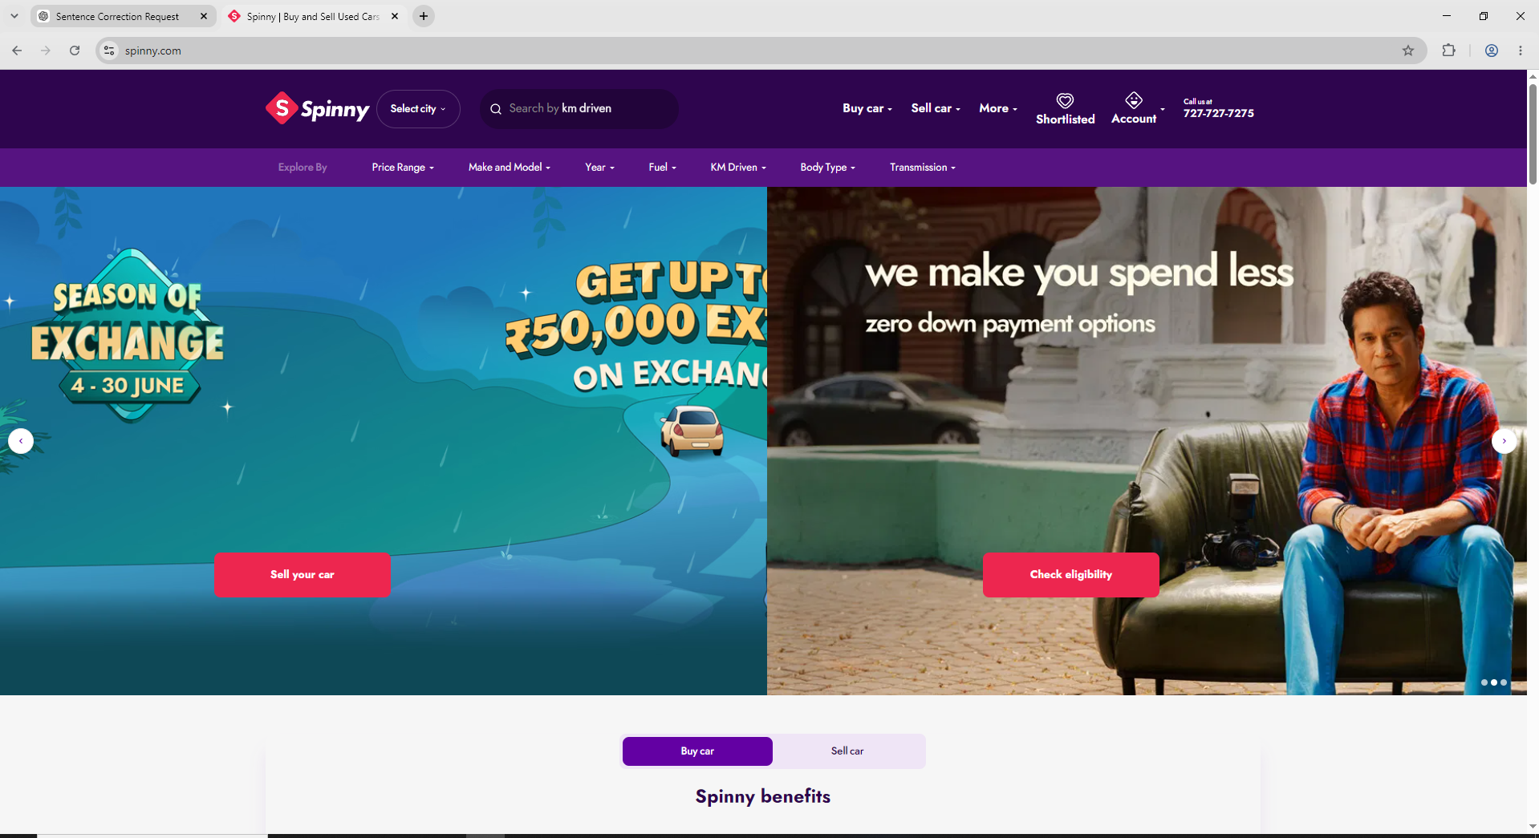

2. Founding Information
Founded in 2015, Spinny was established by Niraj Singh and Mohammad Wahid Khan. The founders identified a major opportunity in India's used-car market where customers lacked trust in vehicle quality, ownership history, and pricing transparency.
Founding Information Table:
Founded Year: 2015
Headquarters: Gurugram, Haryana
Founders: Niraj Singh, Mohammad Wahid Khan
CEO: Niraj Singh
Employee Count: 4000+ (estimated)
Geographic Presence: Major Indian metro cities
Business Model Impact:
The founders intentionally chose an inventory-led model rather than a marketplace model. This strategic decision gave Spinny greater control over vehicle quality and customer experience.

[Insert Screenshot 2: LinkedIn Company Profile]
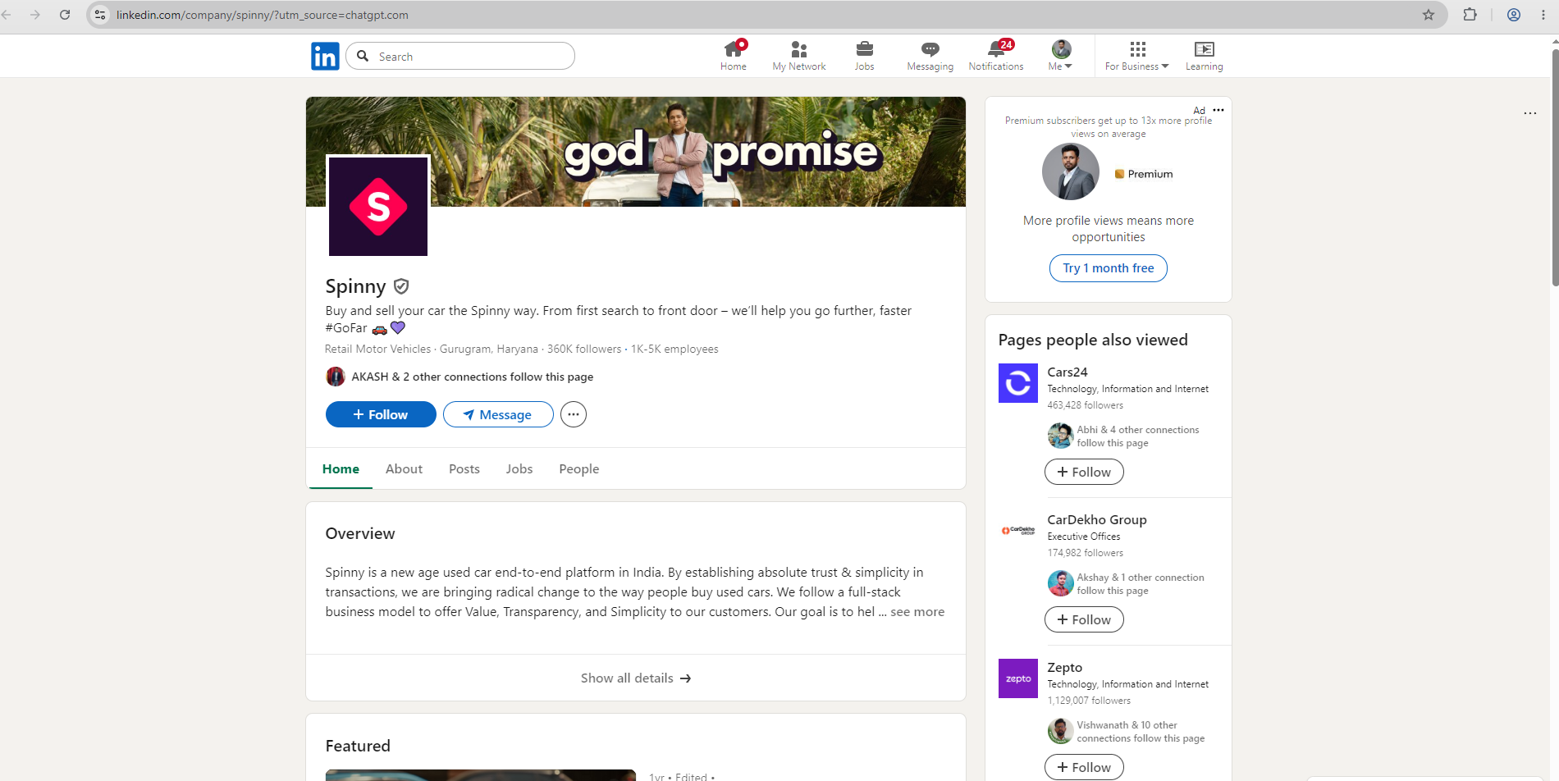

3. Leadership Team Analysis
The leadership team combines expertise in technology, operations, automotive commerce, and consumer internet businesses.
Leadership Contributions:
• Strategic planning
• Technology innovation
• Operational scaling
• Customer experience optimization
• Market expansion
Product Manager Observation:
The leadership structure supports both rapid growth and operational discipline, critical for an inventory-intensive business model.

4. Funding History
Spinny has raised over $1 billion from major investors including Tiger Global, Abu Dhabi Growth Fund, General Catalyst, and Elevation Capital.
Strategic Importance of Funding:
• Geographic expansion
• Technology development
• Refurbishment infrastructure
• Customer acquisition
• Financing ecosystem development
Funding accelerated Spinny's ability to compete with Cars24 and strengthen its brand position.
[Insert Screenshot 3: Crunchbase Funding Page]
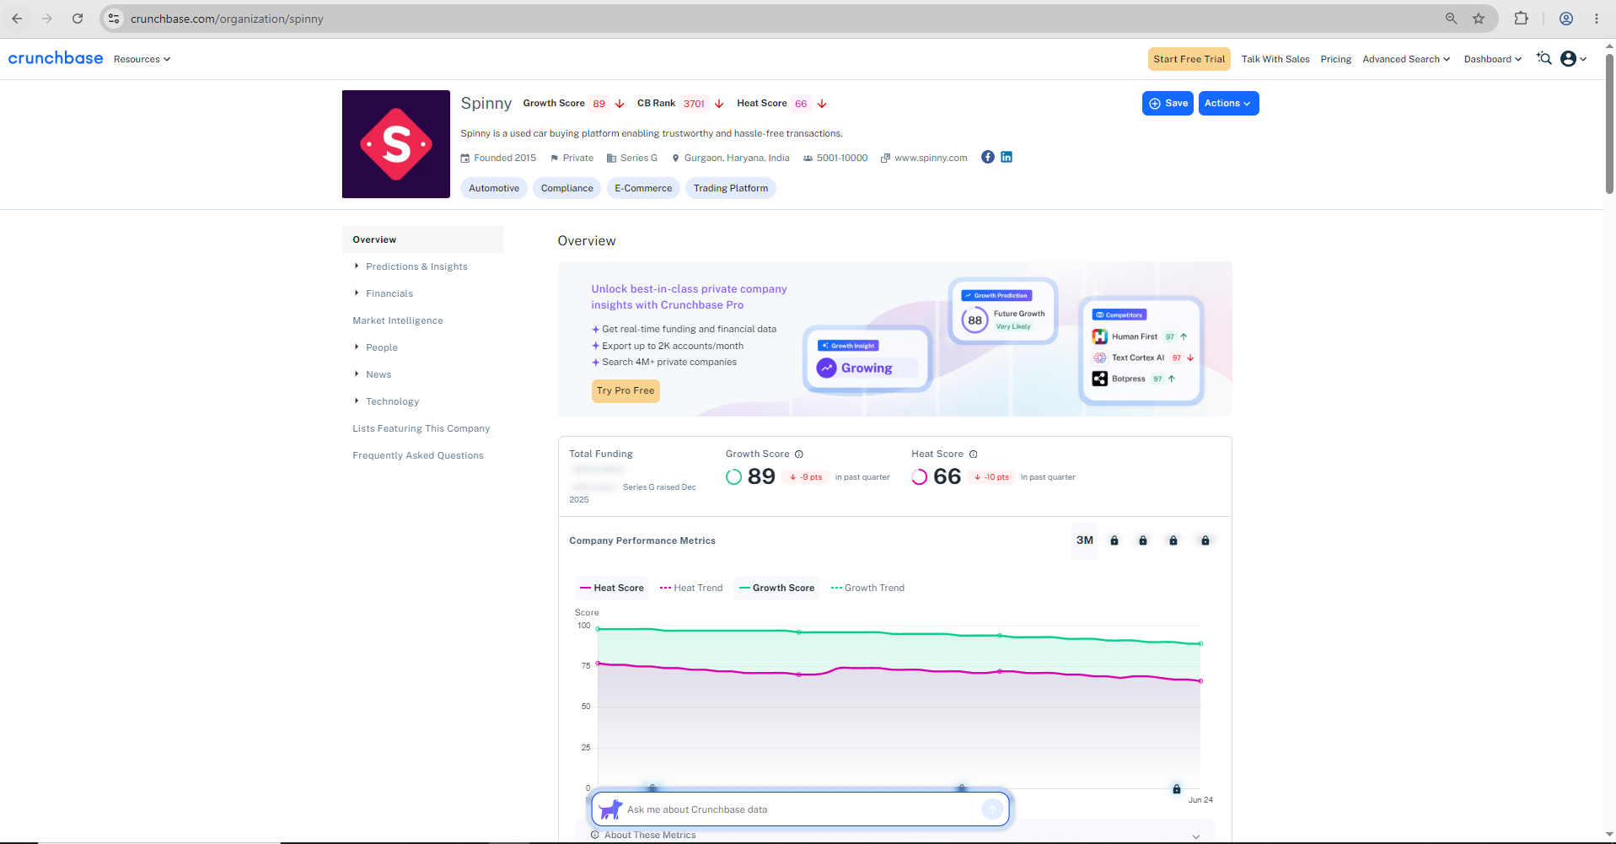

5. Business Model
Spinny follows an inventory-led commerce model.
Revenue Streams:
• Vehicle sales margins
• Financing commissions
• Insurance commissions
• Extended warranties
• Value-added services
Business Model Canvas:
Customer Segments: Buyers and sellers
Value Proposition: Trusted certified used cars
Channels: Website, app, retail hubs
Revenue Streams: Sales, finance, insurance
Key Activities: Inspection, refurbishment, sales
Key Resources: Inventory, technology, brand
Key Partners: Banks, insurers, logistics providers
Strengths:
• End-to-end customer control
• Premium customer experience
• Higher trust levels
• Better pricing consistency
[Insert Screenshot 4: Buy Car Journey]
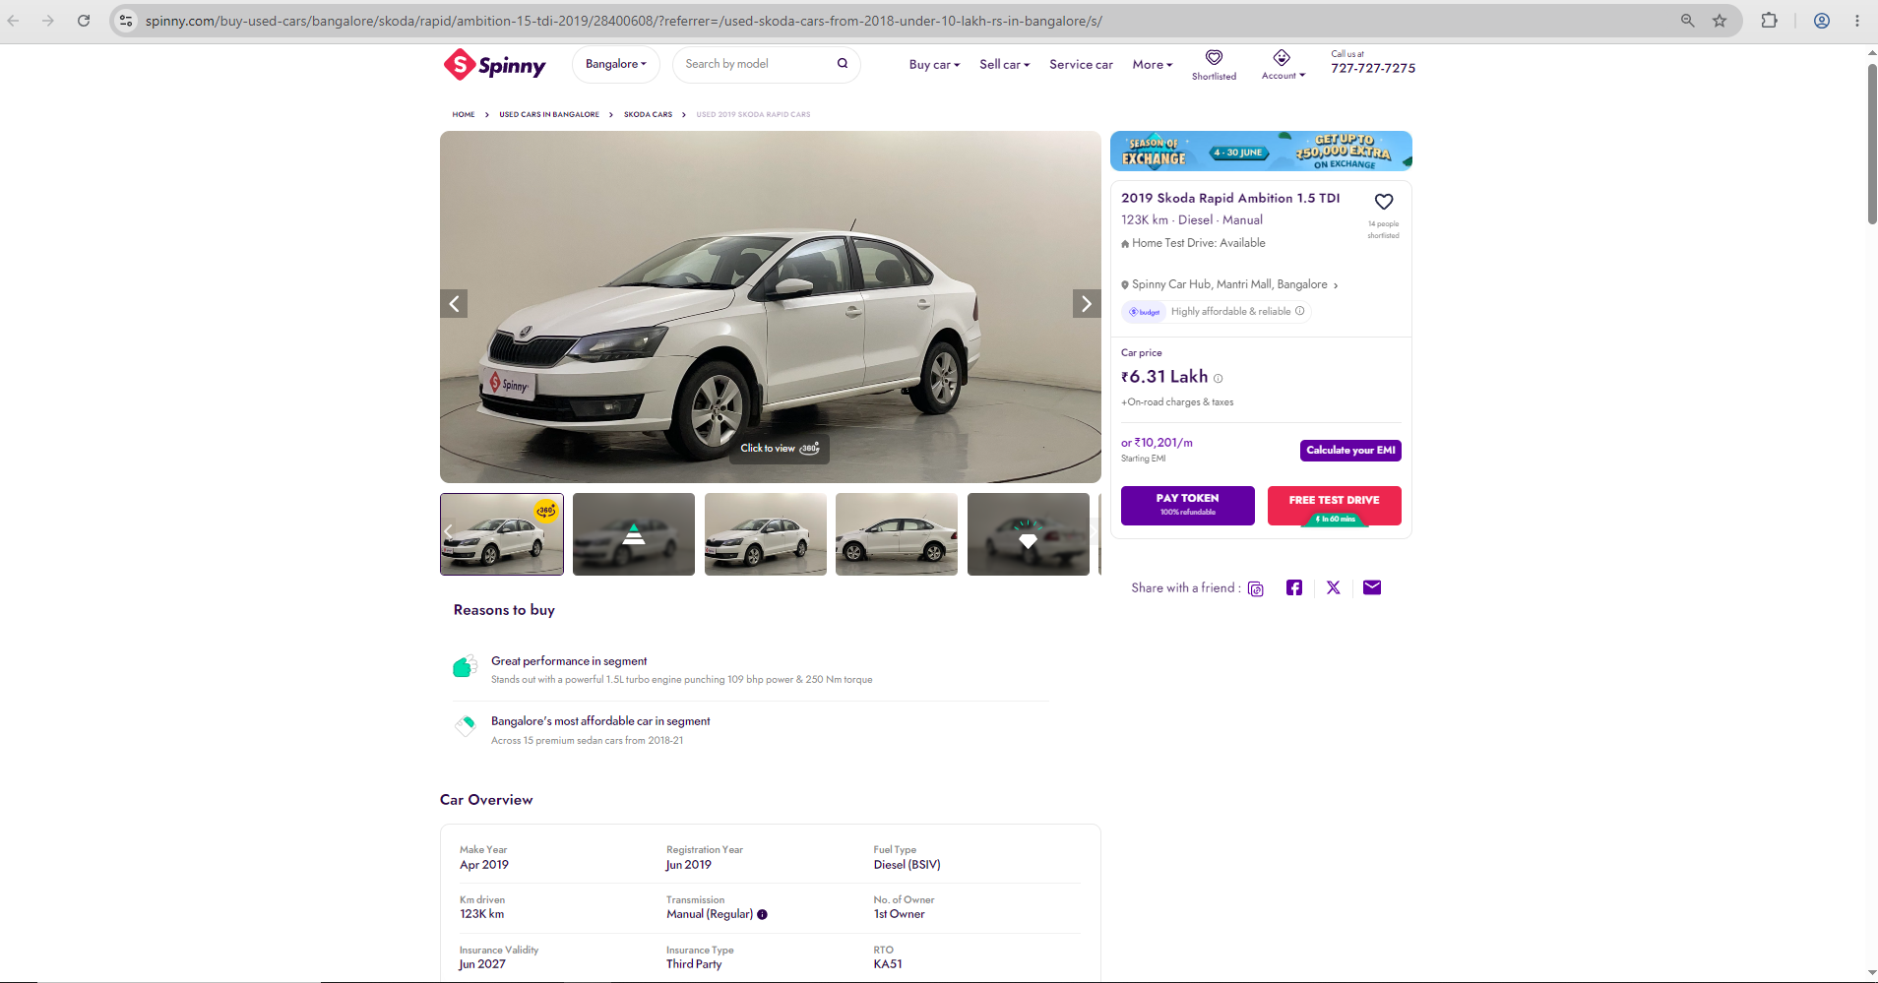
[Insert Screenshot 5: Sell Car Journey]
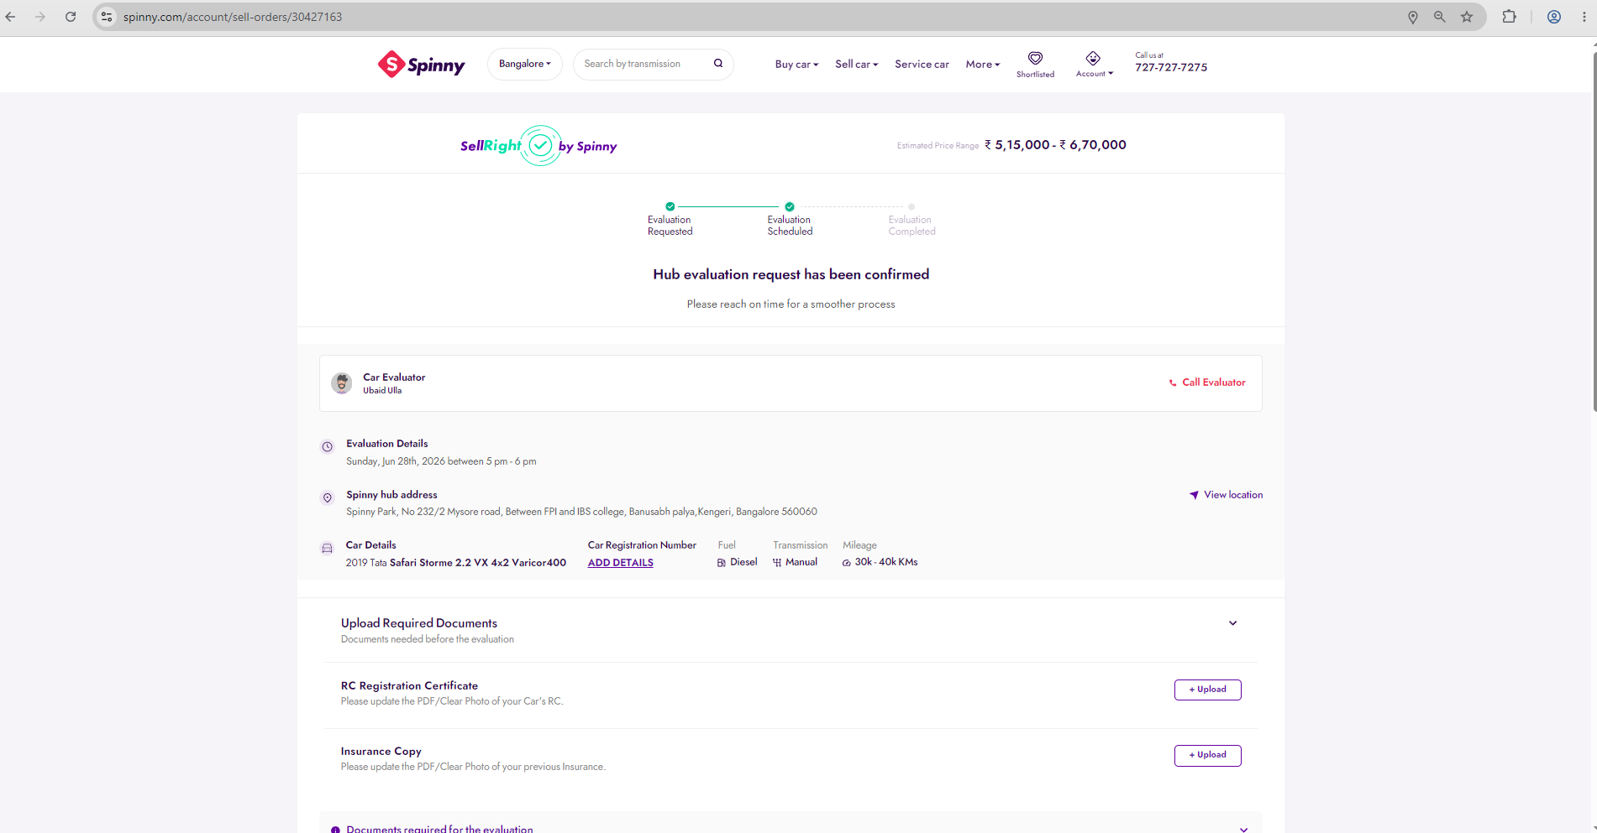

6. Target Customers
Primary Customer Segments:
1. First-Time Buyers
Needs: Affordable mobility
Pain Points: Trust and financing
Why Spinny: Certified vehicles and warranties
2. Working Professionals
Needs: Convenience
Pain Points: Time constraints
Why Spinny: Home test drives and digital experience
3. Families
Needs: Safety and reliability
Pain Points: Vehicle condition concerns
Why Spinny: Inspection and warranty programs
4. Premium Buyers
Needs: High-quality vehicles
Pain Points: Authenticity concerns
Why Spinny: Premium certification process
5. Sellers
Needs: Fast and fair transactions
Pain Points: Price negotiation
Why Spinny: Transparent valuation process
Product Manager Observation:
Spinny segments customers based on needs and purchase motivations rather than demographics alone.

7. Geographic Presence
Spinny operates across India's major urban centers including Delhi NCR, Bengaluru, Hyderabad, Mumbai, Pune, Chennai, Ahmedabad, and Kolkata.
Expansion Strategy:
• Focus on high-demand cities
• Prioritize digital adoption markets
• Hub-and-spoke operational model
• Strong offline experience centers
Market Penetration Approach:
The company targets high vehicle ownership regions with strong purchasing power.
[Insert Screenshot 6: Service Locations Page]

8. Competitive Analysis
Spinny vs Cars24 vs CarDekho
Spinny:
• Premium positioning
• Inventory ownership
• High trust and transparency
Cars24:
• Faster transactions
• Scale-driven approach
• Strong resale ecosystem
CarDekho:
• Marketplace and discovery platform
• Lower operational complexity
• Lead-generation focus
Product Manager Insight:
Spinny differentiates through customer experience rather than transaction volume.

9. Strategic Insights
Insight 1: Trust is the Core Product
Observation: Trust drives customer acquisition.
Evidence: Certified inspections and warranties.
Implication: Higher conversion rates.
Recommendation: Continue investing in trust features.
Insight 2: Inventory Ownership Creates Differentiation
Observation: Spinny controls quality.
Implication: Better customer satisfaction.
Recommendation: Maintain quality standards.
Insight 3: Premium Positioning Works
Observation: Customers value assurance.
Implication: Brand loyalty increases.
Recommendation: Strengthen premium brand messaging.
Insight 4: Financing is a Growth Lever
Observation: Financing expands accessibility.
Implication: Increased conversion.
Recommendation: Expand lending partnerships.
Insight 5: EV Resale Market Opportunity
Observation: EV adoption is increasing.
Implication: New revenue streams.
Recommendation: Build EV certification and battery-health products.

10. Risks, Challenges & Future Opportunities
Major Risks:
• Inventory holding costs
• Capital intensity
• Competitive pressure
• Economic slowdown
Future Opportunities:
• EV resale ecosystem
• Subscription-based ownership
• AI-powered pricing engines
• Vehicle lifecycle services
• Financial products
Product Manager Observation:
Future growth depends on creating recurring revenue streams beyond vehicle transactions.

References & Screenshots
Recommended Screenshots:
1. Spinny Homepage
2. LinkedIn Company Page
3. Crunchbase Funding History
4. Buy Car Journey
5. Sell Car Journey
6. Service Locations
7. Financing Page
8. Vehicle Certification Process
References:
• Spinny Official Website
• Crunchbase
• LinkedIn
• Economic Times
• Business Standard
• Inc42

